**1.Finding the factorial of the given number by the user.**

Flowchart:

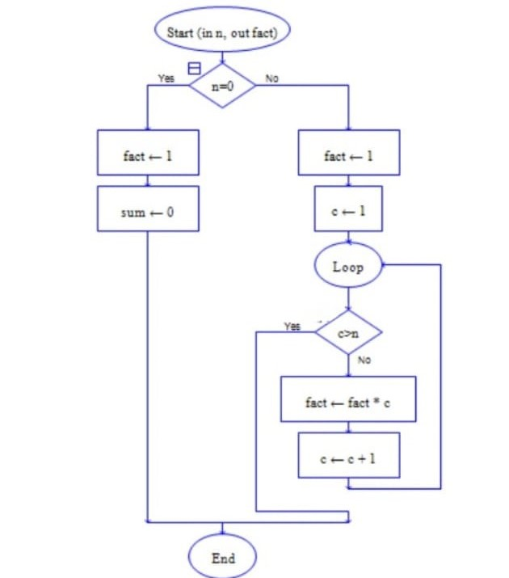

**2.Finding the distance between the two given points.**

Flowchart:

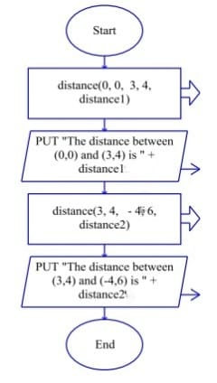

**3.Converting length from feet to centimetre.**

Flowchart:

